

**VMware vCenter**

**Plugin Configuration Guide**

Contents

Introduction 2

vCenter Configuration Checklist 2

Supported Collection Types 2

Data Sources 2

Requirements 2

Firewall Ports 2

User Permission 3

Registry Modification for vCenter 6.7+ 3

Setup 3

Server Properties 3

Field Definitions 3

Appendix A: Disable RC4 in .NET TLS 4

Fix is Described in Microsoft Security Advisory 2960358 4

Technical Support 6

# Introduction

Data collected by the vCenter plugin is used in the VM Protection Analysis report in Bocada.

# vCenter Configuration Checklist

Detailed steps are given in other sections, this is an overview of the steps to configure vCenter collections on your Bocada Data Collection Server:

* Verify username & password for vCenter API access
* Verify required TCP port 443 has been opened
* If you have vCenter 6.7 or above, perform registry modifications to disable RC4 in .NET TLS on the Bocada DCS

# Supported Collection Types

The plugin currently supports the following collection types from vCenter servers:

|  |  |  |
| --- | --- | --- |
| **Collection Type** | **Supported** | **Description** |
| Backup | ✓ | Collects transactional details about snapshots. Example metrics include, start times, durations, bytes, files, errors etc. |
| Storage | ✓ | Collects point-in-time inventory and infrastructure information. Example metrics include ESXi Hosts, Datastores, Datacenters, Folders and Virtual Machines. |
| Policy |  | Collects and stores information on policy attributes, schedules, storage units, storage groups, storage lifecycle policies and clients. |

Note that both Backup jobs and Storage / Occupancy data collections must succeed for the VM Protection Analysis report to be populated.

# Data Sources

The plugin relies on the following vCenter data sources:

* vCenter API

# Requirements

This section lists requirements that must be met prior to collecting data with the Bocada plugin for vCenter:

### **Firewall Ports**

|  |  |  |
| --- | --- | --- |
| **Service** | **Default Port** | **Note** |
| HTTPS | 443 | Outbound from DCS to vCenter API |

### **User Permission**

The Bocada plugin requires access to the vCenter API in order to collect data. A user with a minimum of read access is required to access the vCenter API through the vSphere client (or web client).

### **Registry Modification for vCenter 6.7+**

If you have vCenter 6.7 or above, perform registry modifications on your Bocada DCS to disable RC4 in .NET TLS. Please see Appendix A for instructions how to make this modification.

# Setup

### Server Properties

Backup Server Properties determine how the plugin will interface with the vCenter server and are managed through the Backup Servers view.

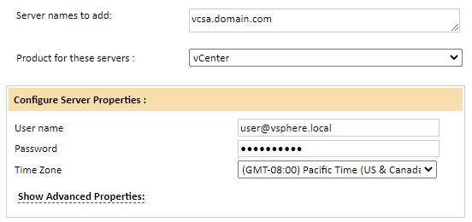

### Field Definitions

#### User Name & Password

Provide the account information to connect to the vCenter server.

#### Time Zone

Select the time zone where vCenter server resides. This setting ensures times are displayed consistently in environments that span multiple time zones.

# Appendix A: Disable RC4 in .NET TLS

Bocada data collection for vCenter 6.7 will sometimes fail with the following error:

Error 545: WebException; The underlying connection was closed: An unexpected error occurred on a send.

This is caused by a Transport Layer Security (TLS) error which requires two registry modifications to disable RC4 in .NET TLS on each Bocada data collection server.

## Fix is Described in Microsoft Security Advisory 2960358

The required change is provided by Microsoft in this Security Advisory:

<https://docs.microsoft.com/en-us/security-updates/SecurityAdvisories/2015/2960358>

Note that this has been tested by Bocada for Windows Server 2016, although the article does not specifically mention this version of windows. Apply the fix to each Bocada DCS.

##### How To Use the Microsoft Instructions

The specific instructions needed are under the following bullet points in the Security Advisory in the following sections. You will need to set at least 2 registry keys, and you may wish to set all 4 keys at this time.

**Manually disable RC4 in TLS on systems running .NET Framework 3.5**

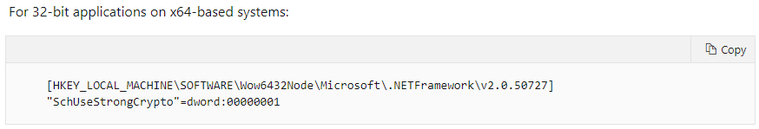

**Manually disable RC4 in TLS on systems running .NET Framework 4.5/4.5.1/4.5.2**

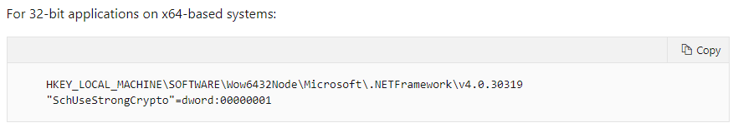

Note that you may need to manually create and set the value for the registry keys as the file-based import method for the registry keys described in the Microsoft article does not always work. When you have finished you should see the keys in regedit.exe like the below screenshots:

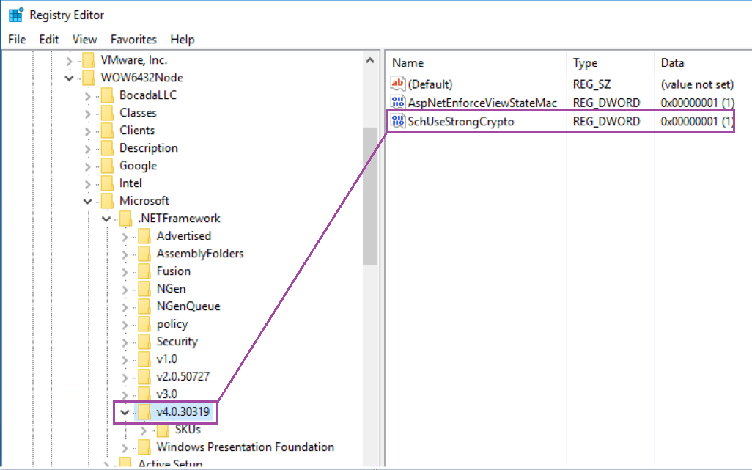

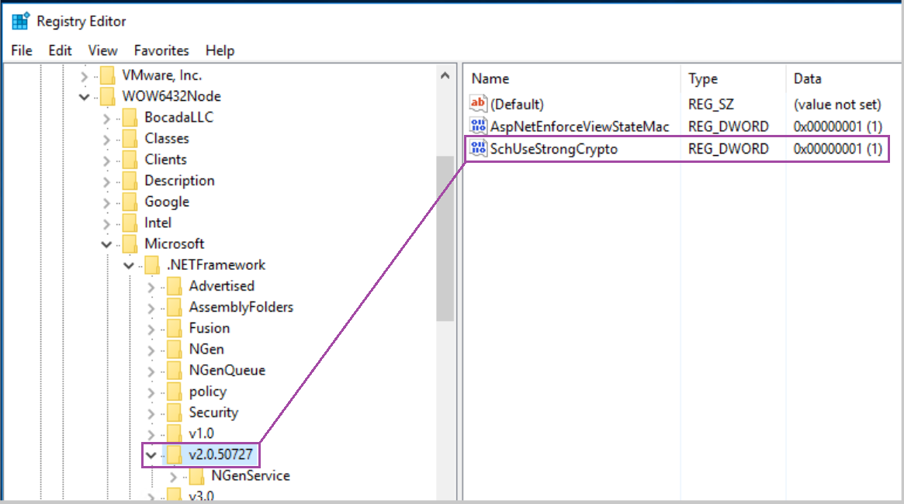

# Technical Support

For technical support or a copy of our standard support agreement, please contact us.

**E-mail:** [support@bocada.com](mailto:support@bocada.com)

**Support Portal:** <https://bocada-support.force.com>

**Phone:** +1-425-898-2400